**DXC Mainframes password instructions for Operations**

Please follow same steps for all below mentioned services in all listed environments below.

* 1. SFBenefitNarrativeAPI

example for Prod directory – \\mp-wss-fw01n01\inetsrv\api\SFBenefitNarrativeAPI

* 1. SubscriberService --

example for Prod directory -\\mp-wss-fw01n01\inetsrv\SubscriberService

* 1. BenefitNarrative

example for Prod directory - \\mp-wss-fw01n01\inetsrv\BenefitNarrative

1. Go to above folder directory for all above API’s in each environment as per below screenshot.

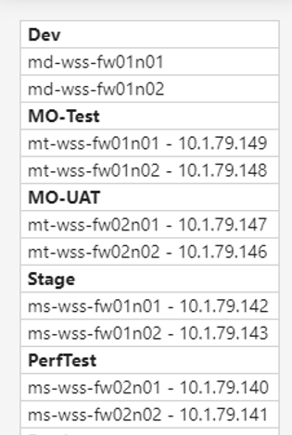

**Prod**

mp-wss-fw01n01 - 10.1.79.130

mp-wss-fw01n02 - 10.1.79.130

mp-wss-fw01n03 - 10.1.79.130

mp-wss-fw01n04 - 10.1.79.130

mp-wss-fw01n05 - 10.1.79.130

mp-wss-fw01n06 - 10.1.79.130

1. All Servers need to be updated with new password in web.config file

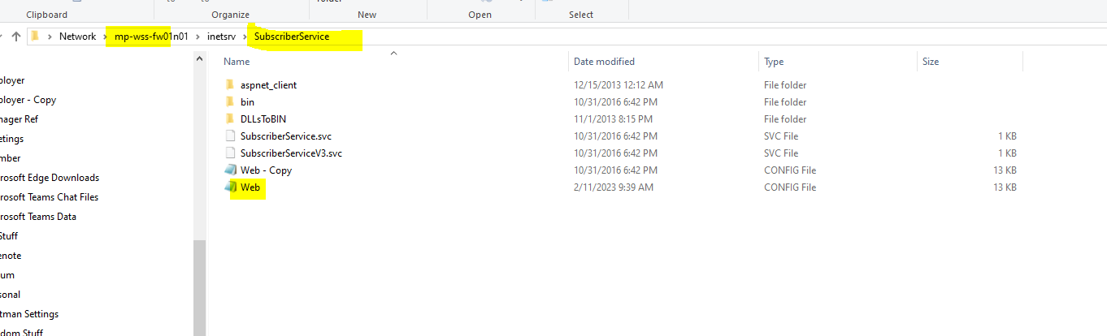

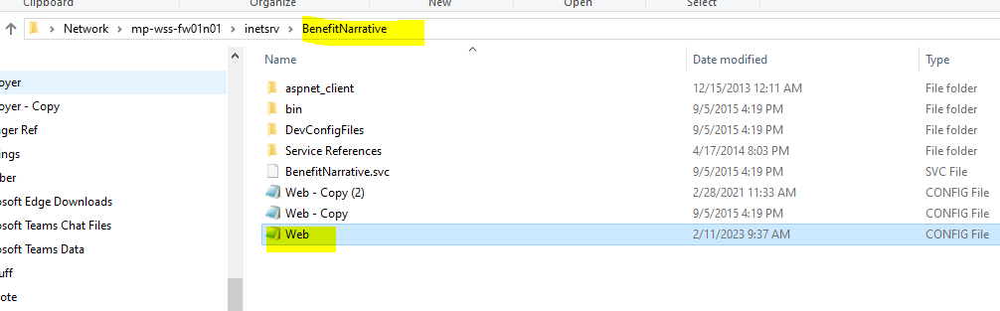

For SFBenefitNarrtiveAPI update appsettings file.

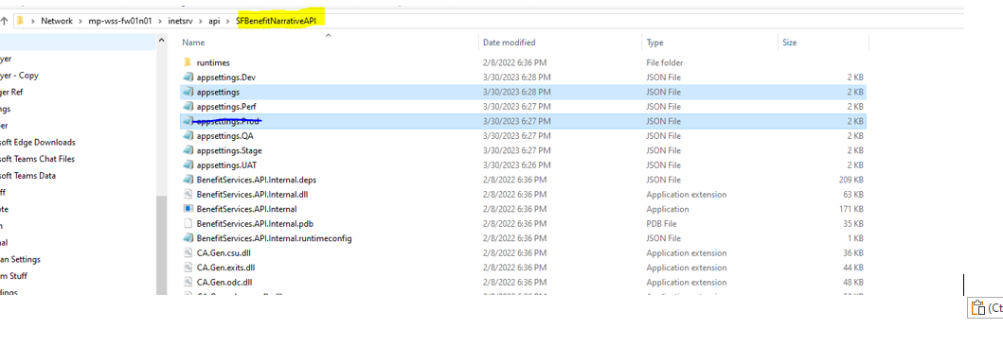

1. Update these two places in as per screenshot below -

ProxyRequestorUserPassword

ProxyClientUserPassword

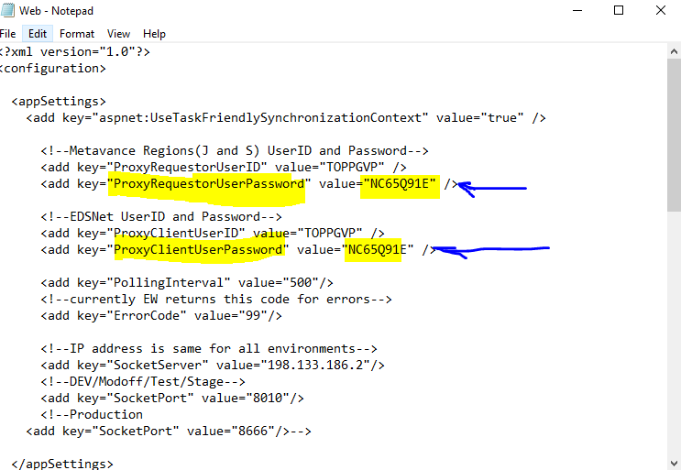

1. After all teams are ready

* Request IIS reset for servers to remove cache passwords to reset at the **end of all pws being updated**. This should be the last step in the process before validation.